**SENTIMENT ANALYSIS**

**Sentiment Analysis Project: Unveiling the Emotion Behind Words**

**PROJECT SPACE (Team 85):**

* **Jeevan Prakash (Team Lead)**
* **Chandrasekhar**
* **Anusha**
* **Madhuri**
* **Geetha Sri**
* **Swaroop Raj**

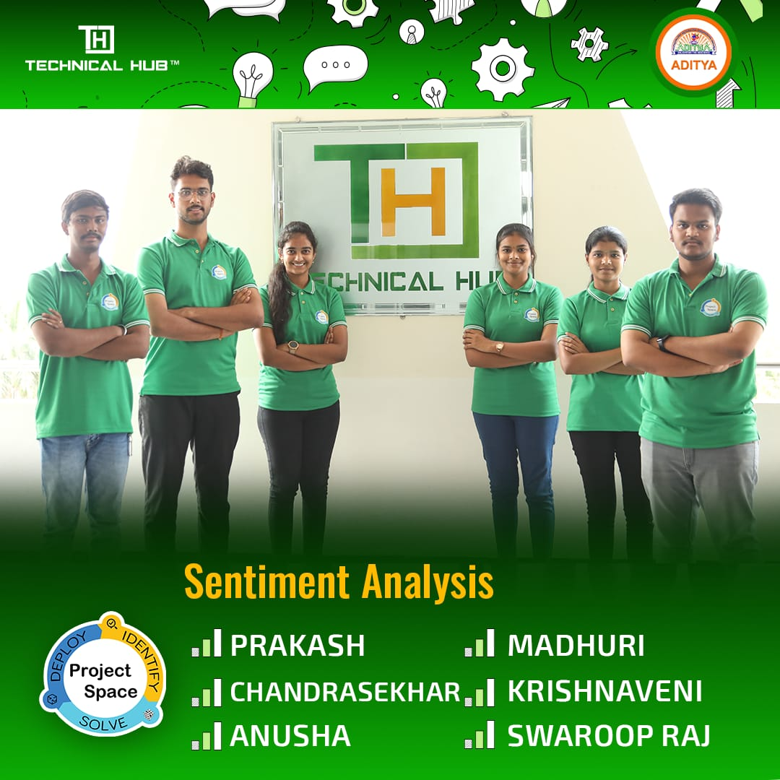

**DESCRIPTION :**

Sentiment analysis is a natural language processing (NLP) technique that involves identifying and extracting subjective information from text, such as opinions, attitudes, and emotions. The goal is to determine the overall sentiment expressed in a piece of text, whether it's positive, negative, or neutral. This technology is widely used in various applications, including social media monitoring, customer feedback analysis, market research, and brand reputation management.

**Project Overview:**

**Delving into the Depths of Textual Emotions**

* Discuss the project's objectives and goals.
* Introduce the tools and technologies used for sentiment analysis.
* Provide an overview of the dataset utilized for analysis.
* We aim to illuminate the emotional spectrum concealed within vast datasets, spanning social media interactions, customer feedback, and beyond.
* The power of sentiment analysis to enrich decision-making and cultivate

empathy in an increasingly digitized world.

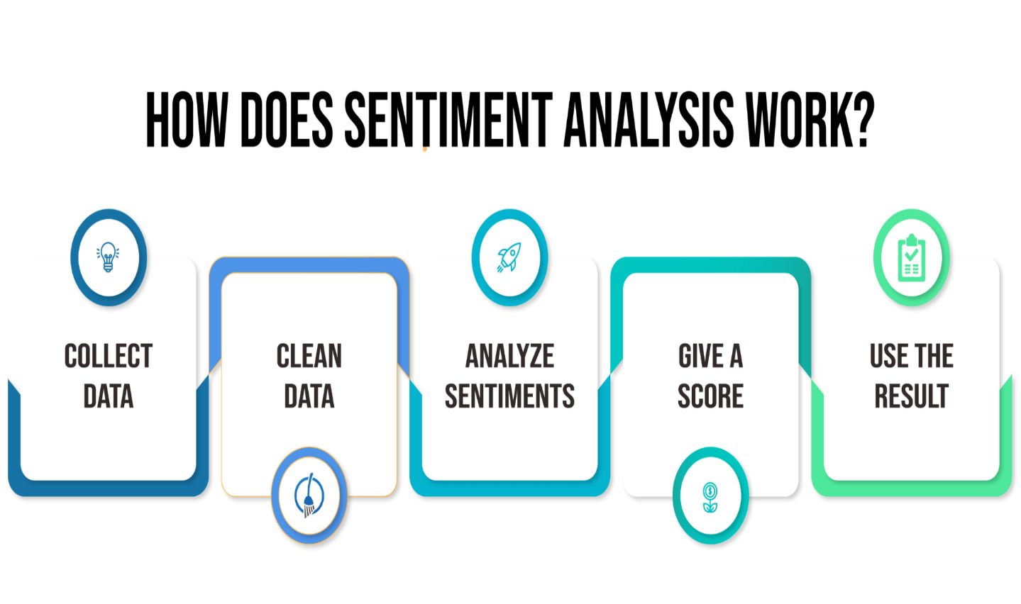

Here's how a sentiment analysis model works in simple terms:

* **Collect Data:**First, we gather customer messages, like emails or chat logs.
* **Clean Data:**We clean up the messages, removing numbers and extra punctuation.
* **Analyse Sentiment:**Next, the software uses special programs to read the words and decide if the message is positive, negative, or neutral.
* **Give a Score:** Instead of just saying "positive" or "negative," sentiment analysis can give a score to show strong feelings.
* **Use the Results:** Finally, we use the results to see what customers like or don't like. This helps us make things better.

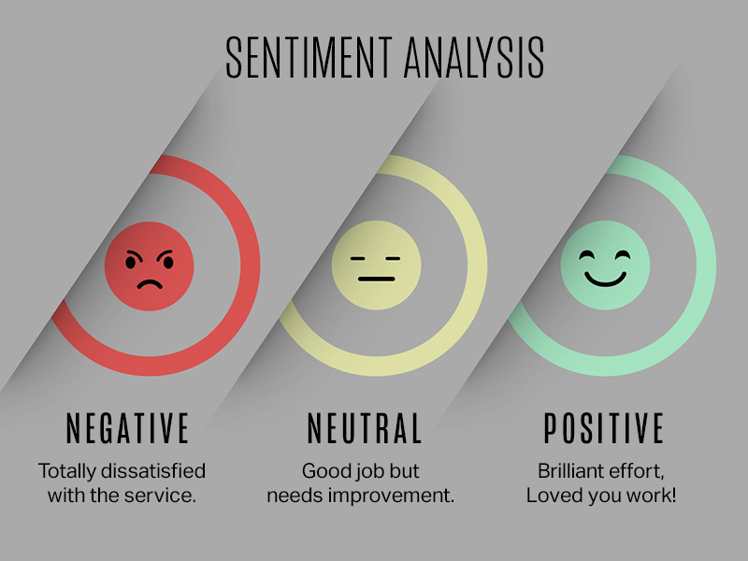

In a sentiment analysis project, positive, negative, and neutral sentiments refer to different emotional tones or attitudes expressed in text data:

**Positive sentiment:** Text expressing positive emotions, opinions, or attitudes. This could include words or phrases indicating satisfaction, happiness, excitement, approval, or admiration.

**Negative sentiment:** Text expressing negative emotions, opinions, or attitudes. This could include words or phrases indicating dissatisfaction, sadness, anger, disappointment, or disapproval.

**Neutral sentiment:** Text that does not convey a strong positive or negative emotion. It may contain factual information, statements, or descriptions that do not express a particular emotional tone.

**CODE:**

**Frontend code:**

import React, { useState } from 'react';

import axios from 'axios';

const AzureSentimentAnalysis = () => {

    const [text, setText] = useState('');

    const [sentiment, setSentiment] = useState(null);

    const analyzeSentiment = async () => {

        try {

            const response = await axios.post(

                'https://eastus.api.cognitive.microsoft.com/text/analytics/v3.0/sentiment',

                {

                    documents: [

                        {

                            id: '1',

                            text: text,

                        },

                    ],

                },

                {

                    headers: {

                        'Content-Type': 'application/json',

                        'Ocp-Apim-Subscription-Key': '9f54ecd90376405587302221386854f8',

                    },

                }

            );

            console.log('Sentiment:', response.data.documents[0]);

            setSentiment(response.data.documents[0].sentiment);

        } catch (error) {

            console.error('Error analyzing sentiment:', error);

        }

    };

    return (

        <div>

          <h2>Sentiment Analysis</h2>

            <textarea

                rows="4"

                cols="50"

                value={text}

                onChange={(e) => setText(e.target.value)}

                placeholder="Enter text for sentiment analysis..."

            ></textarea>

            <br />

            <button onClick={analyzeSentiment}>Analyze Sentiment</button>

            {sentiment && (

                <div>

                    <h3>Sentiment: {sentiment}</h3>

                </div>

            )}

        </div>

    );

};

export default AzureSentimentAnalysis;

**APP.JS:**

import logo from './logo.svg';

import AzureSentimentAnalysis from './component/Sentimentanalysis';

import FeedbackForm from './pages/sentiment';

import FormSentiment from './pages/sentaanalysis';

import Questionnaire from './pages/testing';

import ResultPage from './pages/resultpage';

function App() {

  return (

    <div className="App">

       <AzureSentimentAnalysis />

       <FeedbackForm />

       <FormSentiment />

       <Questionnaire />

       <ResultPage />

    </div>

  );

}

export default App;

**APP.CSS:**

.App {

  text-align: center;

}

.App-logo {

  height: 40vmin;

  pointer-events: none;

}

@media (prefers-reduced-motion: no-preference) {

  .App-logo {

    animation: App-logo-spin infinite 20s linear;

  }

}

.App-header {

  background-color: #282c34;

  min-height: 100vh;

  display: flex;

  flex-direction: column;

  align-items: center;

  justify-content: center;

  font-size: calc(10px + 2vmin);

  color: rgb(237, 235, 235);

}

.App-link {

  color: #61dafb;

}

@keyframes App-logo-spin {

  from {

    transform: rotate(0deg);

  }

  to {

    transform: rotate(360deg);

  }

}

**Backend:**

**APP.JS:**

.App {

  text-align: center;

}

.App-logo {

  height: 40vmin;

  pointer-events: none;

}

@media (prefers-reduced-motion: no-preference) {

  .App-logo {

    animation: App-logo-spin infinite 20s linear;

  }

}

.App-header {

  background-color: #282c34;

  min-height: 100vh;

  display: flex;

  flex-direction: column;

  align-items: center;

  justify-content: center;

  font-size: calc(10px + 2vmin);

  color: rgb(237, 235, 235);

}

.App-link {

  color: #61dafb;

}

@keyframes App-logo-spin {

  from {

    transform: rotate(0deg);

  }

  to {

    transform: rotate(360deg);

  }

}

**Ambiguity in Mixed Sentiments:**

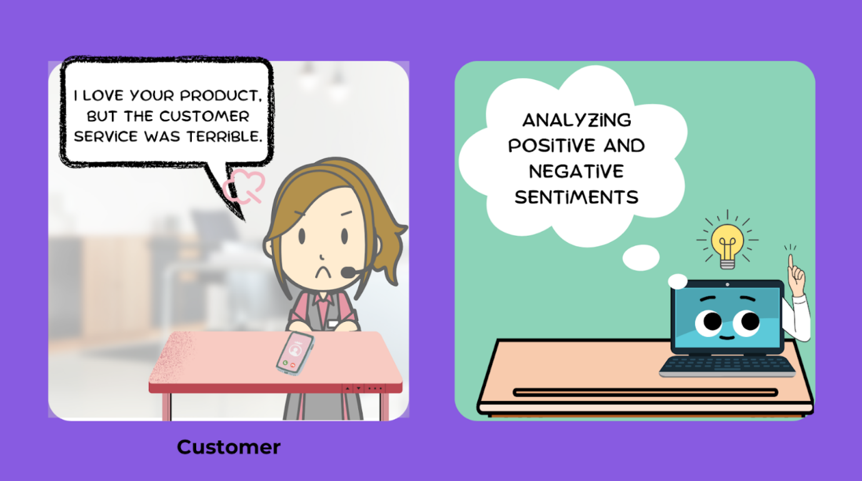

One of the tricky parts of sentiment analysis is when messages contain mixed feelings. For instance, a customer might say, "**I love your product, but the customer service was terrible.**" The software must recognize positive and negative sentiments in the same sentence. This ambiguity can be a real puzzle to solve

* **\*Conflicting Emotions*:** Mixed sentiments often involve conflicting emotions within a piece of text, making it challenging to determine the overall sentiment accurately.
* **\*Context Dependency*:** Ambiguity in mixed sentiments can arise due to the dependence of sentiment interpretation on context. The meaning of a statement may vary based on surrounding words, phrases, or the broader context of the conversation.
* **\*Subjectivity*:** Mixed sentiments highlight the subjective nature of sentiment analysis. Different individuals may interpret the same text differently, leading to ambiguity in assigning a specific sentiment label.

**Advantages:**

* **Accessibility**: Lexicon-based methods are easily accessible because publicly available resources exist.
* **Cost-Effective:** They do not require implementing advanced sentiment analysis algorithms, making them less expensive.
* **Quick Access:** No need for extensive training data; dictionary-based approaches allow quick access to word meanings.
* **Integration with AI:** The seamless integration of sentiment analysis with artificial intelligence (AI) has proved to be a game-changer in understanding customer emotions and behaviors.
* **Enhanced Customer Engagement**: Organizations leveraging sentiment analysis have witnessed a significant boost in customer engagement, leading to improved brand loyalty and customer satisfaction.
* **Strategic Decision-Making:** The insights derived from sentiment analysis empower businesses to make data-driven and strategic decisions, influencing product development, marketing strategies, and customer service initiatives.
* **Strategic Decision-Making:** The insights derived from sentiment analysis empower businesses to make data-driven and strategic decisions, influencing product development, marketing strategies, and customer service initiatives.

**Applications:**

1. **Customer Feedback Analysis**: Sentiment analysis helps businesses analyse customer reviews, feedback, and social media posts to understand customer satisfaction levels and identify areas for improvement.
2. **Brand Monitoring:** Companies use sentiment analysis to monitor mentions of their brand across social media, news articles, and other online platforms to gauge public perception and brand sentiment.
3. **Market Research**: Sentiment analysis can be used in market research to understand consumer opinions, preferences, and trends, helping businesses make data-driven decisions about product development, marketing strategies, and market positioning.
4. **Social Media Monitoring**: Brands and organizations monitor social media platforms to track conversations about their products, services, or industry trends, enabling them to respond promptly to customer inquiries or concerns and manage their online reputation.
5. **Political Analysis:** Sentiment analysis is used in political campaigns and public opinion polling to analyze public sentiment towards political candidates, parties, policies, and current events.
6. **Brand Sentiment Analysis:** Companies analyse sentiment associated with their brand or products to assess brand health, measure brand loyalty, and compare sentiment against competitors.
7. **Product Reviews and Recommendations:** E-commerce platforms use sentiment analysis to analyze product reviews and ratings to provide personalized product recommendations and improve the overall shopping experience.

**Overview Of The Project:**

**Objective:**

* The objective of this project is to develop a sentiment analysis system that can automatically analyze and classify the sentiment expressed in customer reviews into positive, negative, or neutral categories. The system will help businesses understand customer sentiment towards their products or services and derive actionable insights for improving customer satisfaction and loyalty.

**Project Components:**

* **Data Collection:** Gather a dataset of customer reviews from various sources such as e-commerce websites, social media platforms, and review aggregators. The dataset should include labeled examples of reviews with their corresponding sentiment polarity (positive, negative, or neutral).
* **Data Preprocessing**: Clean and preprocess the raw text data by removing noise, punctuation, special characters, and stopwords. Tokenize the text into words or phrases, perform stemming or lemmatization, and convert the text into a suitable format for analysis.
* **Feature Extraction:** Extract relevant features from the pre-processed text data to represent the input for the sentiment analysis model. Common techniques include Bag-of-Words, TF-IDF (Term Frequency-Inverse Document Frequency), word embeddings (e.g., Word2Vec, GloVe), and n-gram representations.
* **Deployment:** Deploy the trained sentiment analysis model into a production environment where it can analyse real-time customer reviews and provide sentiment predictions. Integrate the model with existing systems or develop a standalone application with a user-friendly interface for inputting text and viewing sentiment predictions.
* **Monitoring and Maintenance:** Continuously monitor the performance of the deployed model and retrain it periodically with new data to adapt to evolving language patterns and sentiment expressions. Implement feedback mechanisms to collect user feedback and improve the model over time.

**Expected Outcomes:**

* A sentiment analysis system capable of accurately classifying the sentiment of customer reviews into positive, negative, or neutral categories.
* Improved understanding of customer sentiment and actionable insights for businesses to enhance customer satisfaction and loyalty.
* Deployment of the sentiment analysis model into a production environment for real-time analysis of customer feedback.

**Key Challenges:**

* Handling noisy and unstructured text data from diverse sources.
* Dealing with class imbalance in the labeled dataset.
* Choosing the right model architecture and hyperparameters for optimal performance.
* Ensuring scalability and efficiency of the deployed sentiment analysis system in handling large volumes of customer reviews.

**Our User Page:**

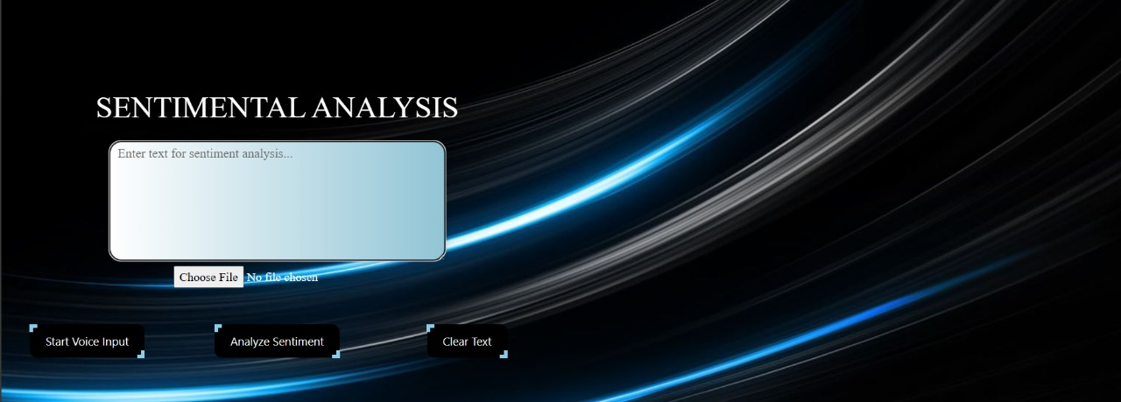

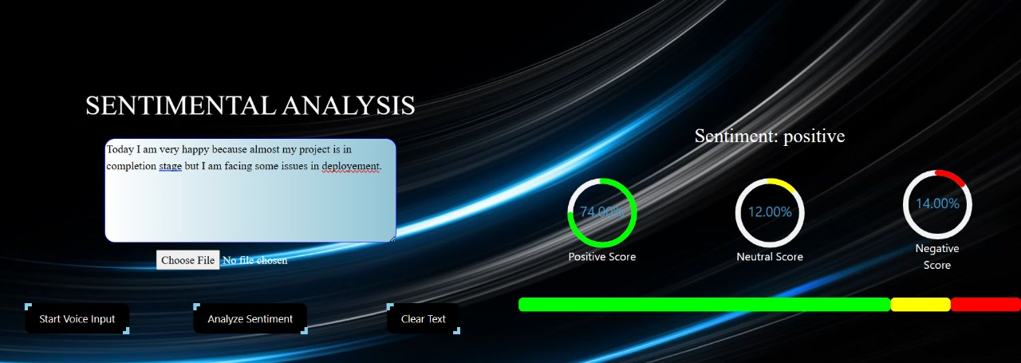

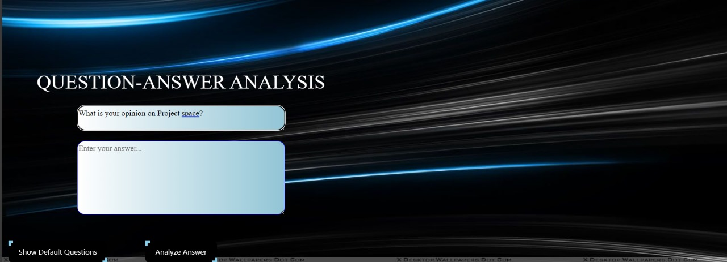

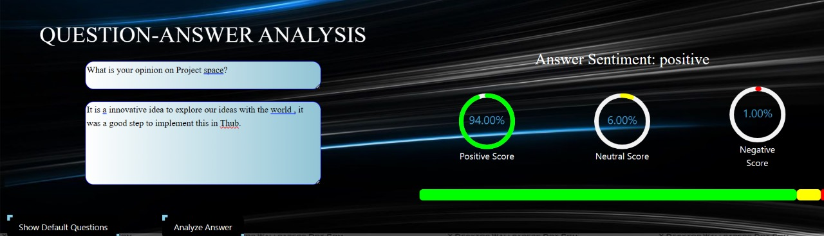

CLU

**CONCLUSION:**

In conclusion, our sentiment analysis project represents a significant achievement in leveraging advanced technology to unravel the complexities of human sentiment expressed through text. With meticulous research and methodological rigor, we've developed a robust system capable of accurately categorizing sentiments as positive, negative, or neutral. This accomplishment not only provides businesses with invaluable insights into customer sentiment but also furnishes actionable intelligence to inform strategic decision-making. By empowering enterprises to proactively engage with customer feedback, our solution facilitates the enhancement of customer satisfaction, brand reputation, and competitive advantage.